V1:
The milestone for V1
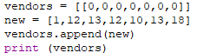
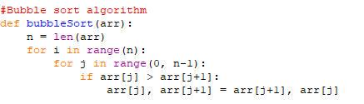
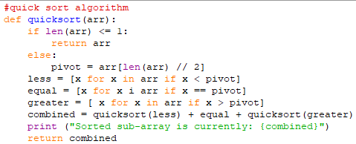
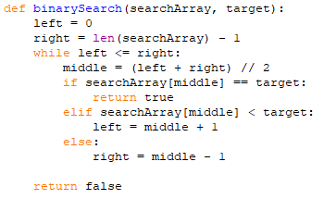
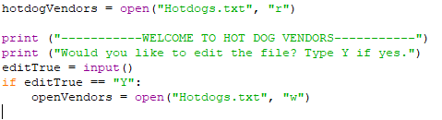
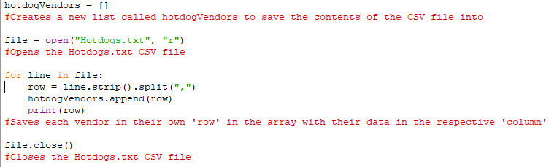
The V1 of my program was mainly creating the early stages of the User Interface, and where I wrote the code to save the external CSV file into an array. While I was doing this in my main program, I had a few external programs to experiment with other code I wanted to add. For example, I had another external program where I tested adding a row to an array separate to when I saved the file as an array, so that I could try to add a title later on. I also had another 3 programs for my binary search, bubble sort and quick sort.

V2:
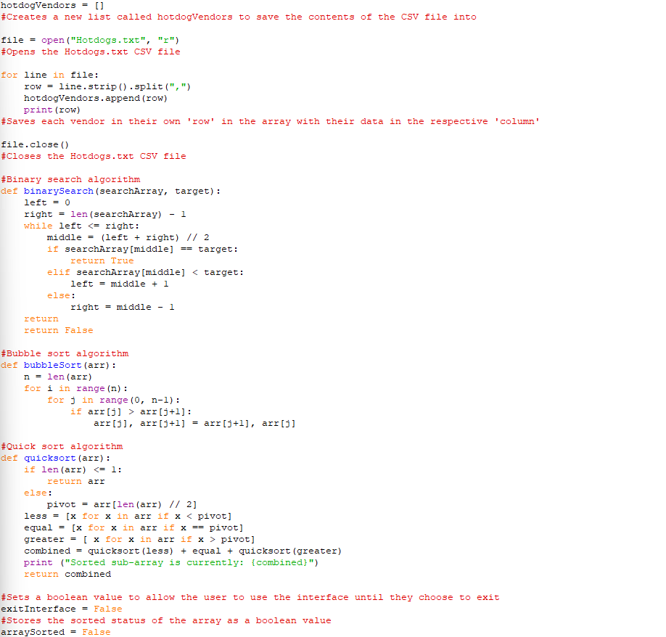
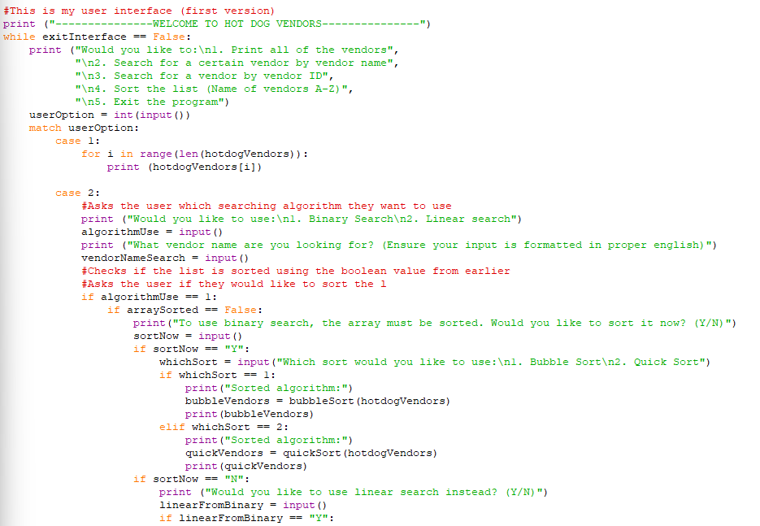
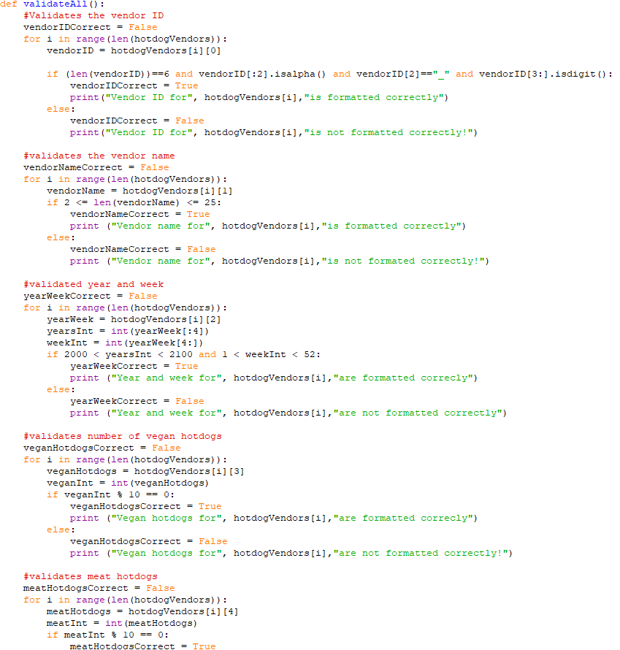
V2 included an expanded User Interface, using a while loop on the condition that exit = false. I used a match case program to allow the user to pick a number from 1 of 5 options, allowing the user to exit the program, search for a vendor by their name or ID, Sort the array (not completed) and print all of the vendors. I also added the search and sort algorithms into my program, but later realised that they only worked for lists, and had to change them to suit a 2D array (in my V3). In case 2 (searching the array) I allowed the user to select which search algorithm they wished to use, and if they picked binary search and the list was not sorted it would give them an error saying that the list must be sorted. They then have the option to sort the list (with a sort algorithm of their choice), or to use linear search instead.

V3:
The milestone for V3 was to complete all of my validation subroutines, and potentially expand the user interface more.
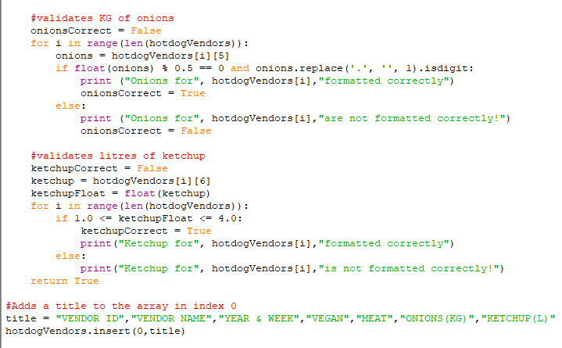
V3 integrated many new things, such as an algorithm for validation of the data in the array and a title row added into the array. I also made a new subroutine to print each line individually, showing the printed array in a more formal and readable way. I added more code to the interface, actually making the exit selection functional and adding more code to sort the list. I made a change to my search options, merging them as one and letting the user search for any data in the array rather than just vendor name and ID. My validation has been tested and works up to standard after some trial and error. My vendor ID validation checks each character individually to make sure that the ID is in the format XX_123. The validation for vendor name checks that the length of the vendor name is between 2 and 25. For my Year and week, I made it save the first four characters in the data as its own variable, followed by the last 2 characters also being saved as a different variable. I then checked that the first variable was between 2000 and 2100, to match the 21st century, and the second variable had to be between 1 and 52 to match the number of weeks in a year. For validating the vegan and meat hotdogs, I had to ensure that the integers were divisible by 10, so I used modulus division and checked that the reminder was 0 after dividing the numbers by 10. For the onions, I had to make sure that the numbers were in 0.5kg increments and is a decimal number. To do this, I used modulus division and divided the numbers in float form using float(onions) by 0.5 to make sure they were all divisible by 0.5, and used the .replace function to check that the last 2 characters in the string were a decimal place and a number, ensuring that the number was a decimal number.

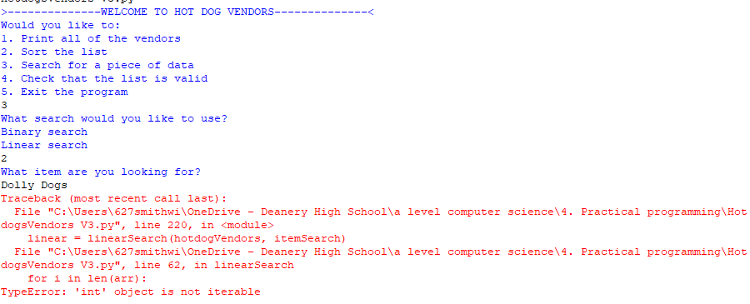
V4:
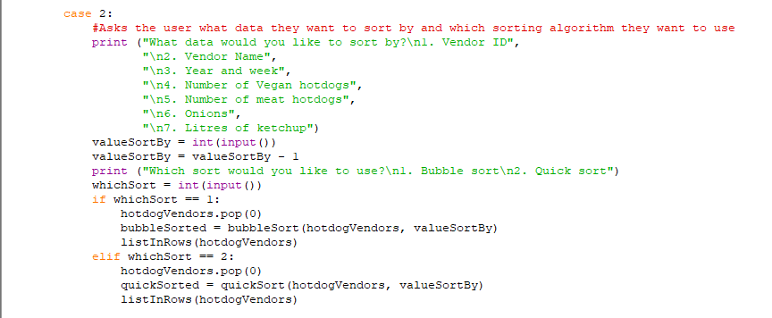
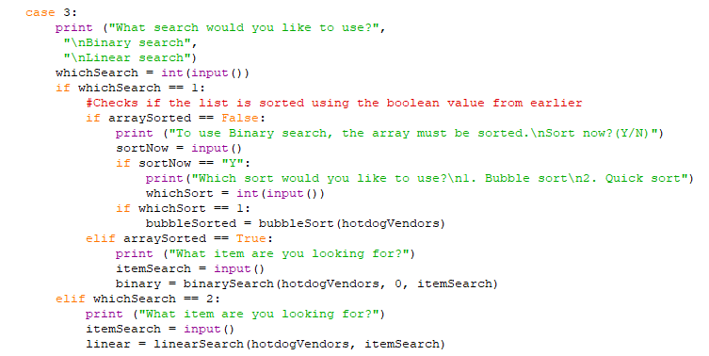
Error encountered in V4, Searching using linear search. I managed to narrow down the error to the subroutine, not global program.

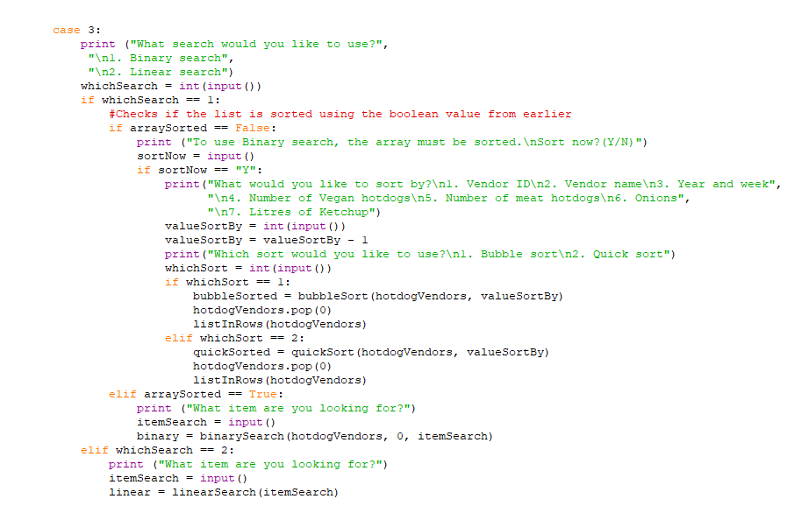
V4 is also when I managed to get my sorting and searching UI options functional. If the user enters ‘2’ when the interface is shown, they will be presented with some text that asks them what data (column) in the array that they wish to sort by. The user then needs to input a number corresponding to which data they want to sort by, and the program will take 1 away from this number to get the index it needs for the algorithm to sort by what the user wants. The sorting algorithms require the array and column that it will be sorted by as arguments. At first, my bubble sort worked, but my quick sort was missing some essential code that includes the column that the algorithm will be sorted by. I encountered some errors when writing the code for the searching option, especially when writing the code for the binary search option. This was mostly due to the fact that I had a validation variable in place to make sure that the array was sorted before using binary search. As of V4, my binary search still doesn’t function properly, as it will give the user the option to sort the array then and there, but does not continue the binary search after sorting. The linear search also does not work, and this will need to be resolved in my V5 as well as adding an edit option and outputting the efficiency of searches and sorts.
V5

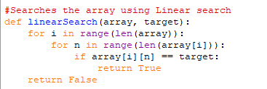
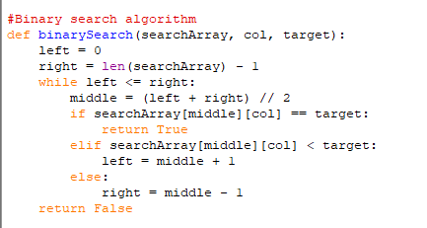
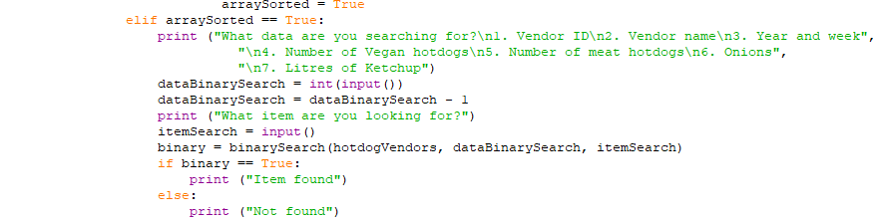
In V5, I mainly focused on fixing the linear and binary search algorithms I made. I found the problems to both searches through trial and error and closer examination of the code. When copying the code from my external python files where I made both the searches, I forgot to adapt the searches to a 2d array instead of a 1d list. I fixed this by adding [col] to the searches in specific locations, which made the binary search functional. The only problem with the binary search is that I think it requires too much input, and it is faster to use linear search, However, my linear search was still not working at this stage, After closer examination of the code where I called upon the subroutine and the code within the subroutine, there was a single if statement that made the subroutine not work. After removing ‘return False’ from an if statement and indenting it only in the subroutine. This allowed the subroutine to return True instead, and accurately told me if the data being searched for is in the array.

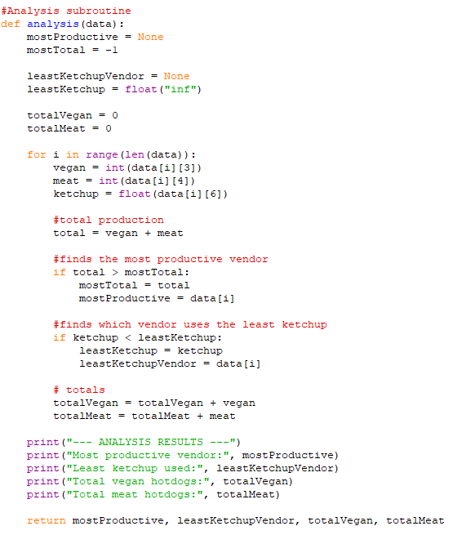
V6
In V6, I implemented a feature that analyses all of the vendors, and outputs the most productive vendor, the vendor that used the least amount of ketchup, and the total number of meat hotdogs and vegan hotdogs. This subroutine will take the hotdogVendors array as an argument. This works by iterating through all of the vendors and comparing all of the data. The data from the array are saved in to variables corresponding to which data they are. For example, the meat hotdogs for the current vendor are saved as a variable named meat, and the amount is found by saving meat as data[i][4] which is the 4th index of the current vendor. The same is done for vegan and ketchup, with vegan being saved into a variable called vegan with data taken from the 3rd index of the current vendor and ketchup is saved as a variable named ketchup with data taken from the 6th index of the current vendor. The subroutine will return the values for the most productive vendor, least ketchup vendor and both hotdog type totals.
Most productive vendor:
This works by adding up the total number of meat hotdogs and vegan hotdogs to find the current vendor’s total output of hotdogs and saves this into a variable called total. When the loop iterates, the previous total is then compared to the current total, and if the current total is greater than the previous, then the most total is updated to with the current value and the vendor this data belongs to is saved as mostProductive. At the end of the loop, the vendor that is saved in this variable is displayed.
Least ketchup:
This works in the same way as the most productive vendor, as the ketchup amount is saved as a variable called leastKetchup but this time when the loop iterates, the if statement is checking if the current data is less than the previous data, and if so then the leastKetchup variable is overwritten and the current vendor info is saved in leastKetchupVendor.
Total meat and vegan hotdogs:
This works by adding the current number of meat hotdogs and vegan hotdogs to a variable called totalMeat and totalVegan. This variable is never overwritten, and only added to by the current vendor. These two variables are also output in the final messages.

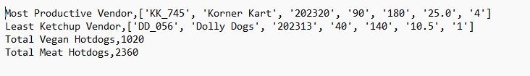
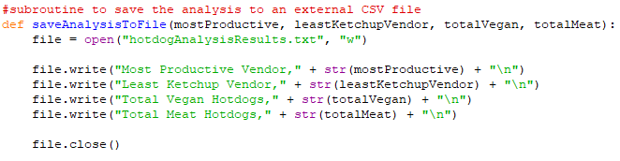
The brief also required me to save the analysis results to an external text file. I implemented this by creating another subroutine called saveAnalysisToFile. The parameters for this subroutine are the same as the returned variables from the analysis subroutine: mostProductive, leastKetchupVendor, totalVegan and totalMeat. The subroutine opens a text file named ‘hotdogAnalysisResults’ and then writes in each of the results on their own line with a related message to display them.

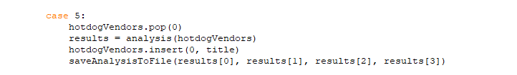
When called, the first thing that happens is the title row of the array is omitted, and then the analysis subroutine is run. The results are saved in a variable called results, which turns into a 1D list with the 4 returned variables from the analysis subroutine. Then, the title row is added back, and the saveAnalysisToFile subroutine is run with results[0], results[1], results[2] and results[3] as arguments. This takes each of the outputs from the initial analysis subroutine and uses them in the external CSV file subroutine.

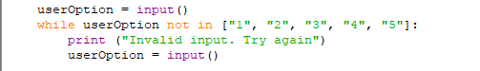
In V6, I also fixed the validation of input for the UI. Previously, the input would need to be between 1-5, or the code would crash. After I fixed it, the input will now be in a while loop until a number 1-5 is input. If the input is not a number between 1-5, then the loop will output the message ‘Invalid input, Try again’ until the input meets the requirements.

Efficiency and comparison
To compare efficiency between my sorts and searches, I needed to add a few more lines of code to each search and sort I implemented. Every search and sort had to open with startTime = time.time() to start the timer. Wherever a value was being returned, I had to add endTime = time.time() to stop the timer. I then found the total and stored it in a variable called timeTaken by subtracting startTime from endTime. For Quick sort, this was different as quick sort is recursive and calls upon itself, so this method would return a time for every recursive call. I had to change the subroutine by defining another subroutine inside the main quick sort code which was the actual ‘quick sort’ part of the subroutine. This way I could add the start and stop around the secondary subroutine to calculate the time of the quick sort itself.

Big O Notation:
The efficiency of an algorithm can be described using Big O notation, which measures how the execution time of an algorithm increases as the size of the dataset grows.
The bubble sort algorithm has a time complexity of O(n²). This means that as the number of records increases, the number of comparisons increases rapidly because each item may need to be compared with every other item. For small datasets the difference may not be noticeable, but for larger datasets bubble sort becomes significantly slower.
The quick sort algorithm has an average time complexity of O(n log n). This makes it much more efficient than bubble sort for large datasets because the number of comparisons grows at a slower rate. As the company expands towards the proposed 4,000 vendors, quick sort would be expected to perform significantly better than bubble sort.
Linear search has a time complexity of O(n) because each item may need to be checked individually until the required value is found. In the worst-case scenario, where the item being searched for is located at the end of the list or is not present at all, every record must be examined before the search can complete.
Binary search has a time complexity of O(log n). Instead of checking every item individually, the algorithm repeatedly halves the remaining search area. This means that even when searching very large datasets, the number of comparisons required remains relatively low. However, binary search can only be used when the data has already been sorted.
The execution times recorded during testing were very small because the supplied dataset contains a relatively small number of vendors. However, the theoretical time complexities show that quick sort and binary search would provide greater performance benefits as the dataset grows larger.

